EBU6304 Software Engineering Group Project

2025-26
Group number | 6
member 1 | QM no: | Name:
member 2 | QM no: | Name:
member 3 | QM no: | Name:
member 4 | QM no: | Name:
member 5 | QM no: | Name:
member 6 | QM no: | Name:
member 7 | QM no: | Name:

First report

Requirements
1. Project Overview
We plan to develop a teaching assistant recruitment system for international schools to replace the current manual Excel-based process.
The system serves three types of users:
TA (Teaching Assistant Applicant): Create profiles, upload CVs, apply for positions, and view application status;
MO (Course Coordinator): Post job openings, screen applicants, hire TAs;
Admin (Administrator): Monitor TA workload.
2. Requirements Gathering Methodology
Process Analysis — Defining Core Data Fields:
Entities | Core Fields
User Profile | Name, Student ID, Major, Grade Level, GPA, Skills, Availability, CV Path
Job | Course Name, Course Code, Responsibilities, Requirements, Number of Openings, Deadline, Posted By
Application | Application Date, Status, Workload

We also interview with an experienced teaching assistant. (for more details, see the supporting materials.)
Key Findings:
What candidates care about most: Being able to quickly find a position that suits them;
MO's top priority: Easily viewing CVs and filtering;
Admin's Top Priority: Preventing students from taking on too many courses at once.
3. Iteration Plan
Iteration 1 (March 22–April 5):
Focus on infrastructure; complete user registration/login, TA profile creation and CV upload, and MO job posting; ensure data is persisted as CSV files; deliver a functional base version;
Iteration 2 (April 5–April 19):
Implement the core recruitment process, including allowing candidates to browse open positions, apply with one click, and enabling managers to view application lists and perform hiring actions, as well as storing and managing application data;
Iteration 3 (May 3–May 17):
Add enhanced features, including application status tracking for candidates, workload monitoring views for administrators, the ability for managers to edit or close job postings, and simple status change notifications;
Iteration 4 (May 17–May 24):
Focus on refinement and delivery, optionally implementing skill-matching recommendations based on timing, completing comprehensive testing, and drafting and recording code documentation, user manuals, and demonstration videos, ultimately submitting the complete software package and final report. The entire plan follows agile principles, ensuring each iteration delivers a demonstrable increment through priority-driven development, dependency mapping, and risk management.
4. Prioritization Strategy
We use the MoSCoW method for prioritization:
Must-have: The system cannot function without this feature | Login, registration, and profile creation
Should have: Core business value; implement as soon as possible | Job applications, filtering and hiring
Could have: Nice to have, but the system will still function without it | Skill matching, notifications
Won't have: Not implemented at this time | Email notifications, data analysis
Sorting criteria:
- User value: Does it address a core pain point?
2) Dependencies: A job posting must exist before an application can be submitted.
3) Technical risks: File read/write functionality will be implemented first; AI matching will follow.
5. Workload Estimation Methods
We use Story Points and Planning Poker:
1.Estimation Criteria:
1 point: Simple task. Modifying a small amount of text on a page, adjusting button positions, etc., requiring almost no additional thought or testing.
3 points: Moderate task. Implementing a basic form submission, simple input validation, and backend data saving.
5 points: Complex task. Typically involves file operations, permission controls, multi-step interactions, or some front-end/back-end coordination, such as a file upload feature.
8 points: Very complex. Involves significant uncertainty, technical challenges, or cross-module interactions, such as AI matching logic that may be introduced in the future.
2.Estimation process:
Task Discussion: For each user story, team members first collectively discuss its scope of implementation, potential technical details, risks, and acceptance criteria to ensure everyone has a consistent understanding of the story.
Anonymous Voting: Each member independently selects a playing card corresponding to a point value, then reveals their card simultaneously to prevent the first speaker from influencing others’ judgments.
Discussing Discrepancies: If there is a significant discrepancy in point values (e.g., one person rates it 3 points while another rates it 8 points), the person who gave the highest and lowest ratings must each explain their reasoning. The team then reanalyzes the task’s complexities, breaking it down into subtasks or clarifying requirements as necessary.
Reaching Consensus: After 1–2 rounds of discussion, the team votes or negotiates to determine the final story points and records them as a basis for future tracking.
3.Estimation Results:
Total Story Points: 61
Iteration 1: 21 points (estimated completion in 2 weeks).
Iteration 2: 18 points.
Iterations 3–4: Remaining 22 points.
- Prototype Design Description
We created a medium-fidelity prototype using Figma, which includes the following core pages:
TA Page:
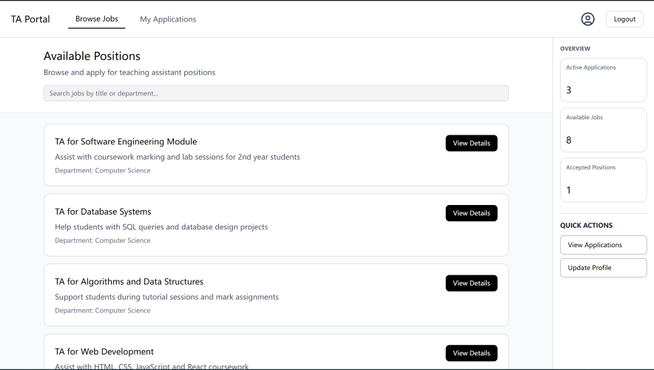
MO Page:
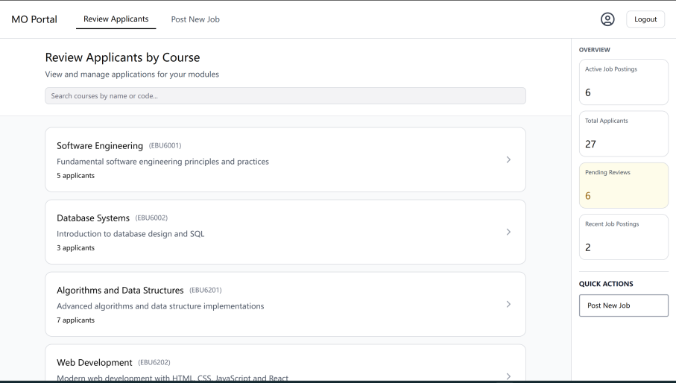
Admin Page:
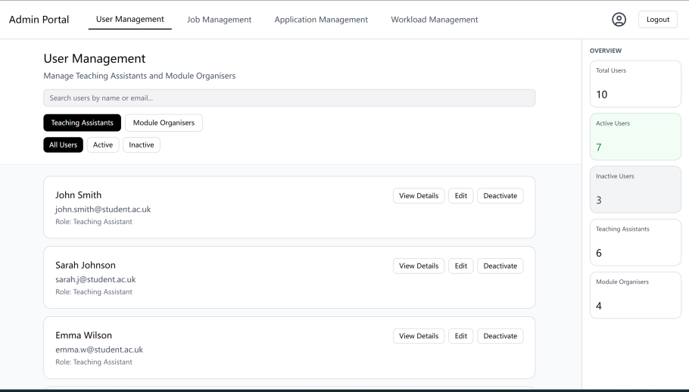
Design Principles: Simple and clear, minimizing the number of clicks; Highlight key information; Align with user habits.

Supporting material
The following Q&A is based on our consultation with Xu Chen, a graduate student with extensive experience as a teaching assistant.
Conclusions:
1. The student has limited channels for finding job openings, and information is often delayed. This project aims to address this issue.
2. While there are differences in the workload between courses, they are not significant. However, since we cannot generalize based on a few examples, we have categorized the workload into four levels.
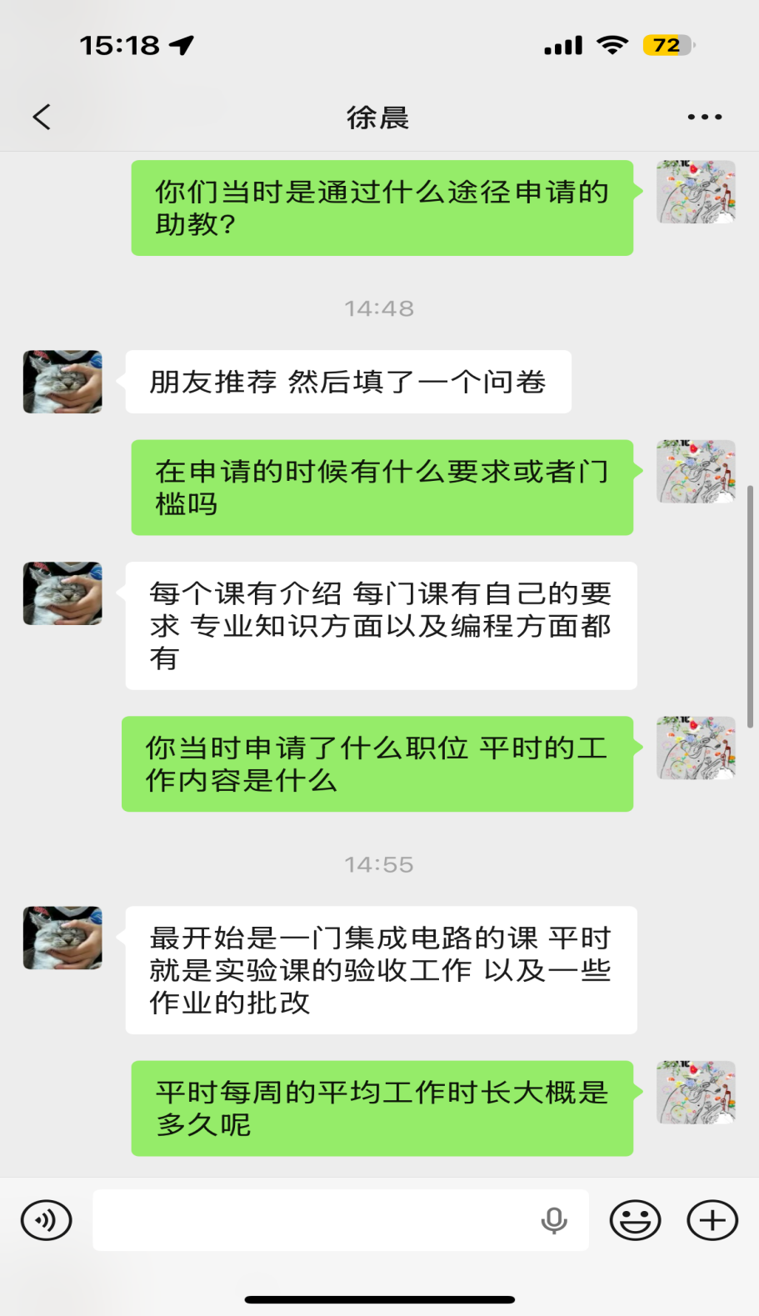
Ask: How did you apply for the teaching assistant position at that time?
Answer: Recommended by friends, then filled out an application form.

Ask: Are there any requirements or thresholds when applying?
Answer:Each course has an introduction, and each course has its own requirements, including professional knowledge and programming aspects.

Ask: What position did you apply for at that time? What is your daily job content?
Answer: At first, it was an integrated circuit course, and usually involved experimental class inspection work and grading assignments.
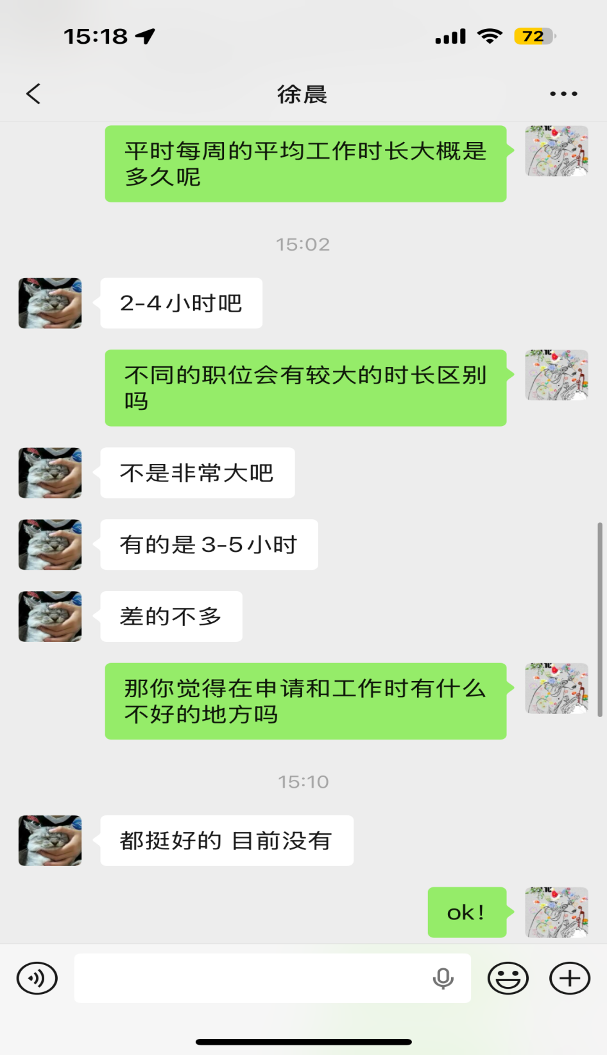
Ask: What is the average weekly working hours usually like?
Answer: About 2-4 hours.

Ask: Are there significant differences in working hours for different positions?
Answer: It's not very big. Some are 3-5 hours. No much difference.

